**Exercise 3: Stored Procedures**

**Scenario 1: Process monthly interest for all savings accounts.**

SQL

CREATE OR REPLACE PROCEDURE ProcessMonthlyInterest

IS

BEGIN

-- Update balance for all savings accounts

UPDATE Accounts

SET Balance = Balance * 1.01

WHERE AccountType = 'Savings';

COMMIT;

DBMS_OUTPUT.PUT_LINE('Monthly interest processed for all savings accounts.');

EXCEPTION

WHEN OTHERS THEN

ROLLBACK;

DBMS_OUTPUT.PUT_LINE('Error processing monthly interest: ' || SQLERRM);

END;

/

EXEC ProcessMonthlyInterest;

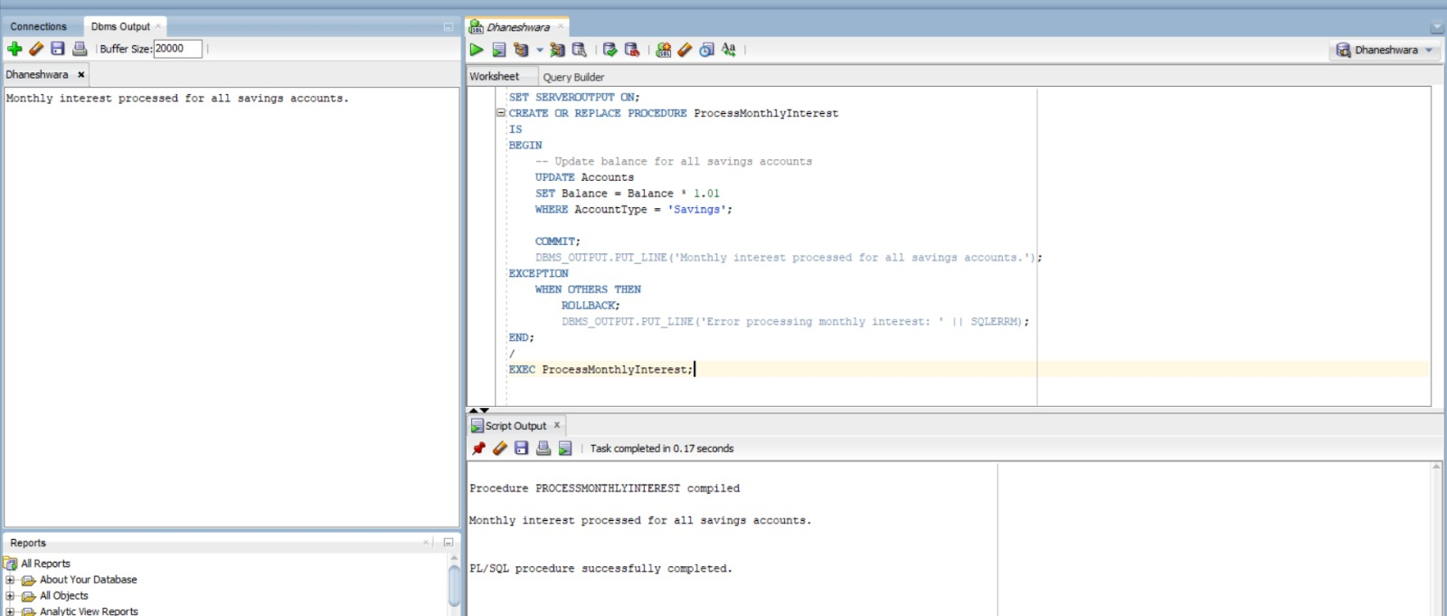

**Scenario 2: Implement a bonus scheme for employees.**

SET SERVEROUTPUT ON;

CREATE OR REPLACE PROCEDURE UpdateEmployeeBonus (

p_department IN VARCHAR2,

p_bonus_pct IN NUMBER -- e.g., pass 10 for 10%

) AS

v_bonus_amt NUMBER;

BEGIN

DBMS_OUTPUT.PUT_LINE('--- Bonus Update for Department: ' || p_department || ' ---');

FOR emp_rec IN (

SELECT EmployeeID, Department, Salary

FROM Employees

WHERE Department = p_department

) LOOP

-- Calculate bonus

v_bonus_amt := emp_rec.Salary * (p_bonus_pct / 100);

-- Display ID, Dept, and Bonus

DBMS_OUTPUT.PUT_LINE('ID: ' || emp_rec.EmployeeID ||

' | Dept: ' || emp_rec.Department ||

' | Bonus: ' || TO_CHAR(v_bonus_amt, '999999.00'));

-- Update salary

UPDATE Employees

SET Salary = Salary + v_bonus_amt

WHERE EmployeeID = emp_rec.EmployeeID;

END LOOP;

COMMIT;

DBMS_OUTPUT.PUT_LINE('--- Bonus Applied Successfully ---');

END;

/

EXEC UpdateEmployeeBonus('IT',10);

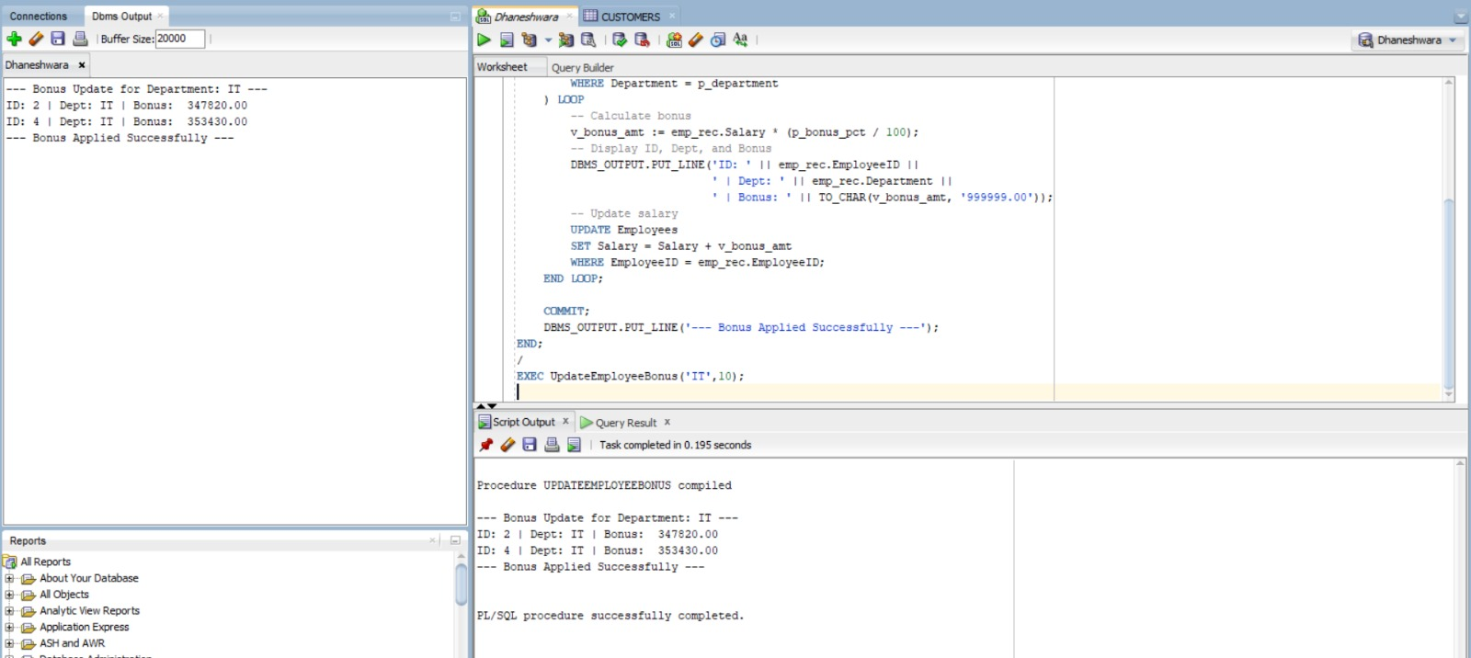

**Scenario 3: Customers should be able to transfer funds between their accounts.**

CREATE OR REPLACE PROCEDURE TransferFunds (

p_source_account_id IN NUMBER,

p_destination_account_id IN NUMBER,

p_amount IN NUMBER

)

IS

v_source_balance NUMBER;

e_insufficient_funds EXCEPTION;

PRAGMA EXCEPTION_INIT(e_insufficient_funds, -20001); -- Custom exception for insufficient funds

BEGIN

-- Check if source account has sufficient balance

SELECT Balance

INTO v_source_balance

FROM Accounts

WHERE AccountID = p_source_account_id

FOR UPDATE; -- Lock the row to prevent concurrent updates

IF v_source_balance < p_amount THEN

RAISE e_insufficient_funds;

END IF;

-- Deduct from source account

UPDATE Accounts

SET Balance = Balance - p_amount

WHERE AccountID = p_source_account_id;

-- Add to destination account

UPDATE Accounts

SET Balance = Balance + p_amount

WHERE AccountID = p_destination_account_id;

-- Record transactions

INSERT INTO Transactions (TransactionID, AccountID, TransactionDate, Amount, TransactionType)

VALUES (TRANSACTIONS_SEQ.NEXTVAL, p_source_account_id, SYSDATE, p_amount, 'Withdrawal');

INSERT INTO Transactions (TransactionID, AccountID, TransactionDate, Amount, TransactionType)

VALUES (TRANSACTIONS_SEQ.NEXTVAL, p_destination_account_id, SYSDATE, p_amount, 'Deposit');

COMMIT;

DBMS_OUTPUT.PUT_LINE('Successfully transferred ' || p_amount || ' from Account ' || p_source_account_id || ' to Account ' || p_destination_account_id || '.');

EXCEPTION

WHEN NO_DATA_FOUND THEN

ROLLBACK;

DBMS_OUTPUT.PUT_LINE('Error: One or both account IDs not found.');

WHEN e_insufficient_funds THEN

ROLLBACK;

DBMS_OUTPUT.PUT_LINE('Error: Insufficient funds in source account ' || p_source_account_id || '.');

WHEN OTHERS THEN

ROLLBACK;

DBMS_OUTPUT.PUT_LINE('An error occurred during fund transfer: ' || SQLERRM);

END;

/

BEGIN

TransferFunds(2,3,500);

END;

/

